Name: DUOP YIEN DUOP
Date: 28th, September, 2026
Course: Software Engineering Essentials
Class title: Student

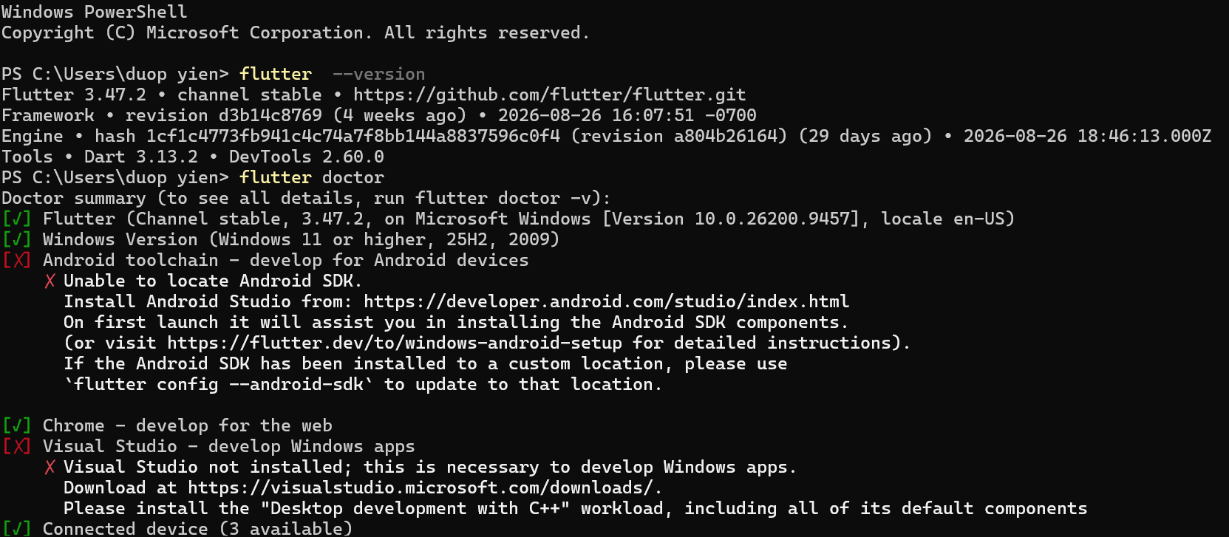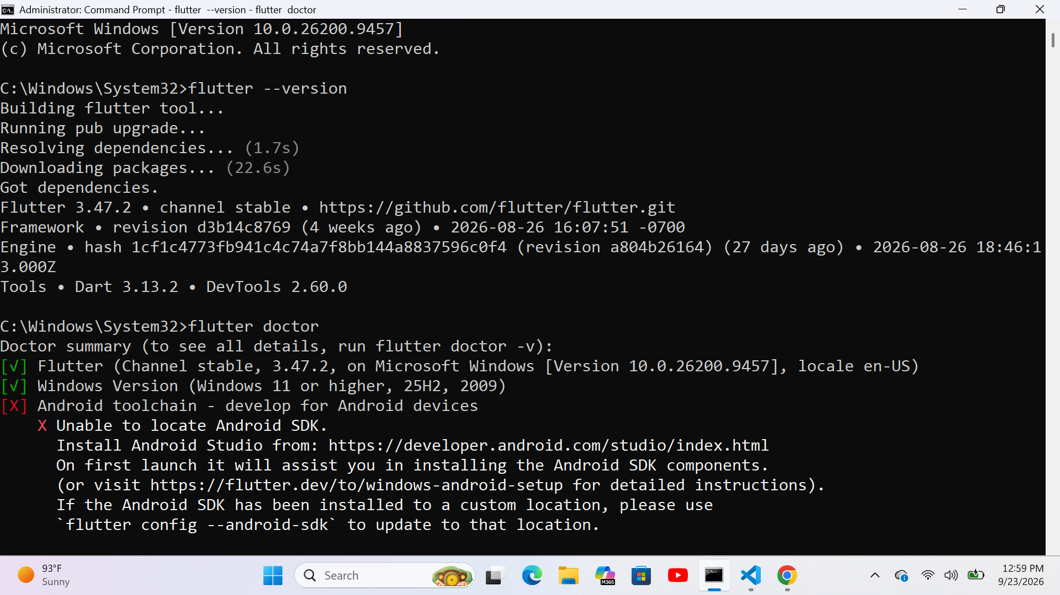

Hot Reload;allows to update the currently running Flutter application with latest changes made to the code without rebuilding the whole application. In most cases, it will preserve the current state of the application. It is better to use Hot Reload while making changes to user interface, styles arrangement code structure or other non-essential parts of the program.
Hot Restart rebuilds; Flutter application and restarts it anew wiping all previous state. It is better to use Hot Restart when changes are made to the part of the code that determines the application’s start and beginning of the execution. In some cases, Hot Reload may fail to apply some changes correctly thus making Hot Restart necessary.

Task 2: MySQL Database Management

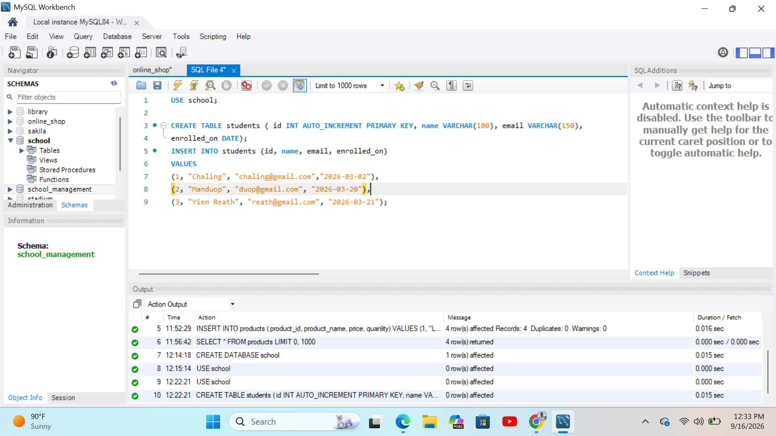

It is not advisable to use the MySQL root account to connect directly to the application backend since it gives too much control over the database server. Furthermore, it violates the principle of least privilege. In case somebody gets access to the root account credentials, they will be able to drop databases, alter data, create new accounts, and perform other operations with the database the application backend since it gives too much control over the database server. Furthermore, it violates the principle of least privilege. In case somebody gets access to the root account credentials, they will be able to drop databases, alter data, create new accounts, and perform other operations with the database.

Task 3: Python Environment & Dependency Isolation,

Creation commands; cd Python_Setup_Lab
Activation command; Set-ExecutionPolicy and env\Scripts\activate
package installation; pip install requests

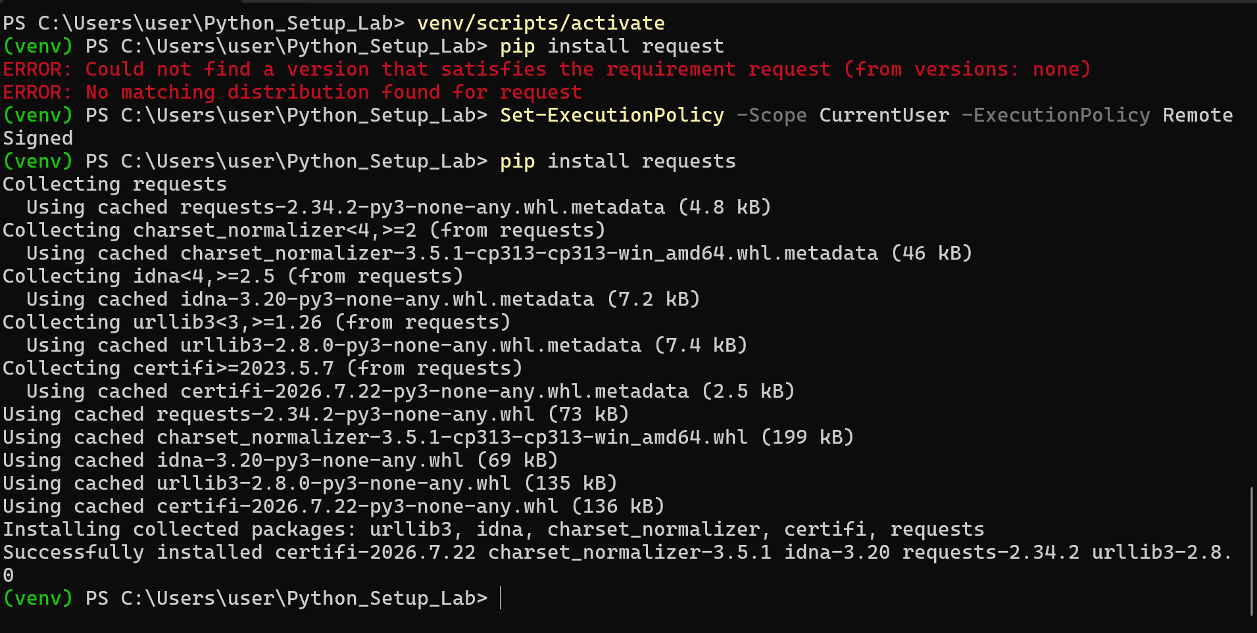

Task 4: VS Code Workspace Configuration



